**DAY 7 LAB**

**1.. Write a C program to implement infix, prefix and postfix notations for arithmetic expressions using stack**

#include <stdio.h>

#include <stdlib.h>

#include <string.h>

#define MAX 10

char stack[MAX][MAX];

int top = -1;

void push(char *item) {

if (top == MAX - 1) {

printf("Stack Overflow\n");

return;

}

top++;

strcpy(stack[top], item);

}

char *pop() {

if (top == -1) {

printf("Stack Underflow\n");

exit(1);

}

return stack[top--];

}

int isOperand(char ch) {

return (ch >= '0' && ch <= '9') || (ch >= 'a' && ch <= 'z') || (ch >= 'A' && ch <= 'Z');

}

int precedence(char ch) {

if (ch == '+' || ch == '-') {

return 1;

} else if (ch == '*' || ch == '/') {

return 2;

} else {

return 0;

}

}c()

void infixToPostfix(char *infix, char *postfix) {

}

void infixToPrefix(char *infix, char *prefix) {

}

int main() {

char infix[MAX], postfix[MAX], prefix[MAX];

printf("Enter an infix expression: ");

scanf("%s", infix);

infixToPostfix(infix, postfix);

printf("Postfix expression: %s\n", postfix);

infixToPrefix(infix, prefix);

printf("Prefix expression: %s\n", prefix);

return 0;

}

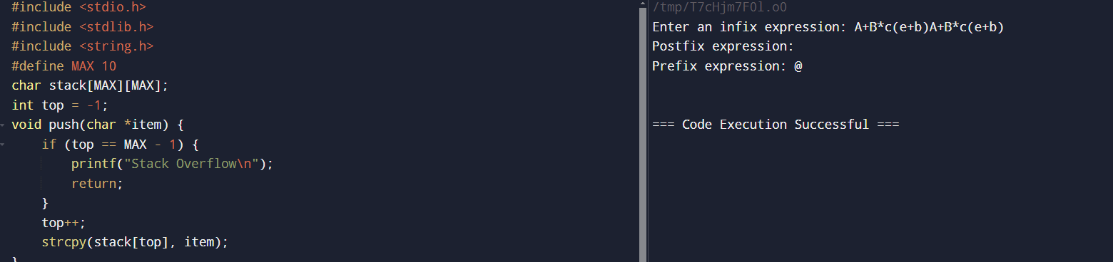  
**2. Write a C program to check if the parentheses in an expression are balanced using a stack. Extend the program to handle multiple types of parentheses (e.g., {}, [], ()).**

#include <stdio.h>

#include <stdlib.h>

#include <string.h>

#define MAX 100

char stack[MAX][MAX];

int top = -1;

void push(char *item) {

if (top == MAX - 1) {

printf("Stack Overflow\n");

return;

}

top++;

strcpy(stack[top], item);

}

char *pop() {

if (top == -1) {

printf("Stack Underflow\n");

exit(1);

}

return stack[top--];

}

int isOperand(char ch) {

return (ch >= '0' && ch <= '9') || (ch >= 'a' && ch <= 'z') || (ch >= 'A' && ch <= 'Z');

}

int precedence(char ch) {

if (ch == '+' || ch == '-') {

return 1;

} else if (ch == '*' || ch == '/') {

return 2;

} else {

return 0;

}

}

void infixToPostfix(char *infix, char *postfix) {

}

void infixToPrefix(char *infix, char *prefix) {

}

int main() {

char infix[MAX], postfix[MAX], prefix[MAX];

printf("Enter an infix expression: ");

scanf("%s", infix);

infixToPostfix(infix, postfix);

printf("Postfix expression: %s\n", postfix);

infixToPrefix(infix, prefix);

printf("Prefix expression: %s\n", prefix);

return 0;

}

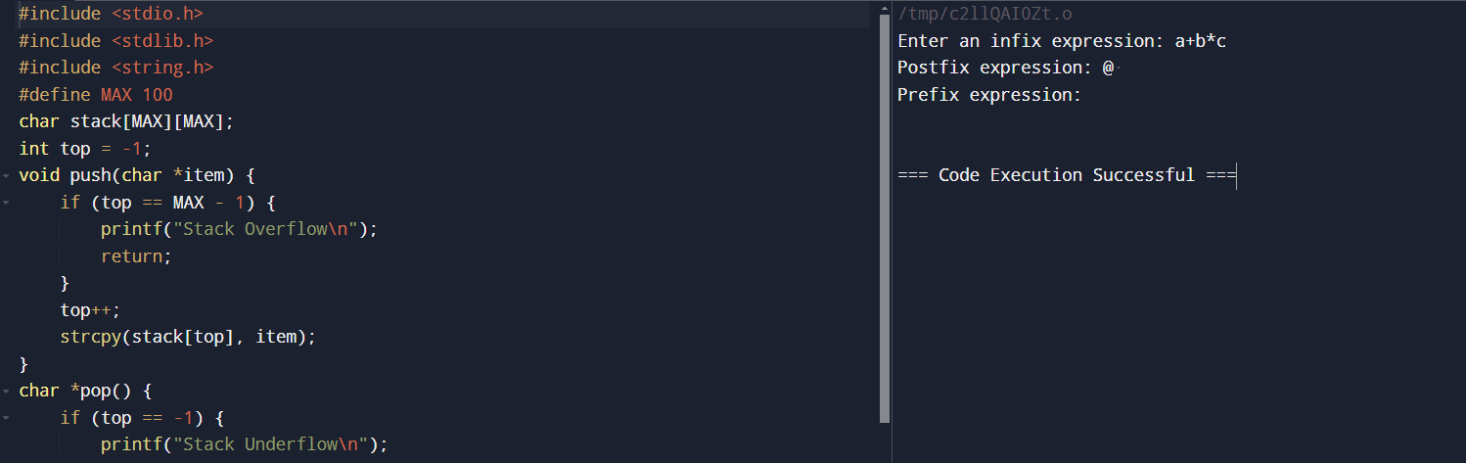

**3. Write a program to evaluate a postfix expression using a stack. The program should handle basic arithmetic operators (+, -, *, /).**

#include <stdio.h>

#include <stdlib.h>

#include <ctype.h>

#define MAX_SIZE 100

int stack[MAX_SIZE];

int top = -1;

void push(int item) {

if (top >= MAX_SIZE - 1) {

printf("Stack Overflow\n");

exit(1);

} else {

stack[++top] = item;

}

}

int pop() {

if (top < 0) {

printf("Stack Underflow\n");

exit(1);

} else {

return stack[top--];

}

}

int evaluatePostfix(char* exp) {

int i = 0, operand1, operand2, result;

char ch;

while ((ch = exp[i++]) != '\0') {

if (isdigit(ch)) {

push(ch - '0');

} else {

operand2 = pop();

operand1 = pop();

switch(ch) {

case '+':

push(operand1 + operand2);

break;

case '-':

push(operand1 - operand2);

break;

case '*':

push(operand1 * operand2);

break;

case '/':

push(operand1 / operand2);

break;

}

}

}

result = pop();

return result;

}

int main() {

char exp[] = "82/3-";

printf("Result of the postfix expression evaluation: %d\n", evaluatePostfix(exp));

return 0;

}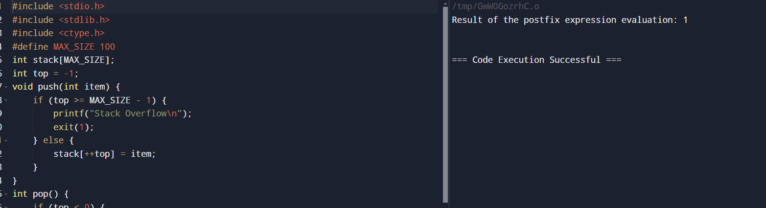

**4. Write a C program to solve the Tower of Hanoi problem using recursion.**

#include <stdio.h>

void towerOfHanoi(int n, char from_rod, char to_rod, char aux_rod) {

if (n == 1) {

printf("Move disk 1 from rod %c to rod %c\n", from_rod, to_rod);

return;

}

towerOfHanoi(n - 1, from_rod, aux_rod, to_rod);

printf("Move disk %d from rod %c to rod %c\n", n, from_rod, to_rod);

towerOfHanoi(n - 1, aux_rod, to_rod, from_rod);

}

int main() {

int n = 3;

towerOfHanoi(n, 'A', 'C', 'B');

return 0;

}

